**DAILY ONLINE ACTIVITIES SUMMARY**

|  |  |  |  |  |  |  |  |  |
| --- | --- | --- | --- | --- | --- | --- | --- | --- |
| **Date:** | **19-05-2020** | | | | | **Name:** | **Ashwini** | |
| **Sem & Sec** | **A** | | | | | **USN:** | **4AL17CS017** | |
| **Online Test Summary** | | | | | | | | |
| **Subject** | | **Computer Graphics and Visualization** | | | | | | |
| **Max. Marks** | | **60** | | **Score** | | | **41** | |
| **Certification Course Summary** | | | | | | | | |
| **Course** | **Front end development HTML** | | | | | | | |
| **Certificate Provider** | | | **Greatlearning** | | **Duration** | | | **3 hr** |
| **Coding Challenges** | | | | | | | | |
| **Problem Statement:Finding shortest palindrome** | | | | | | | | |
| **Status:completed** | | | | | | | | |
| **Uploaded the report in Github** | | | | | **yes** | | | |
| **If yes Repository name** | | | | | **coding** | | | |
| **Uploaded the report in slack** | | | | | **no** | | | |

Online Test Details:

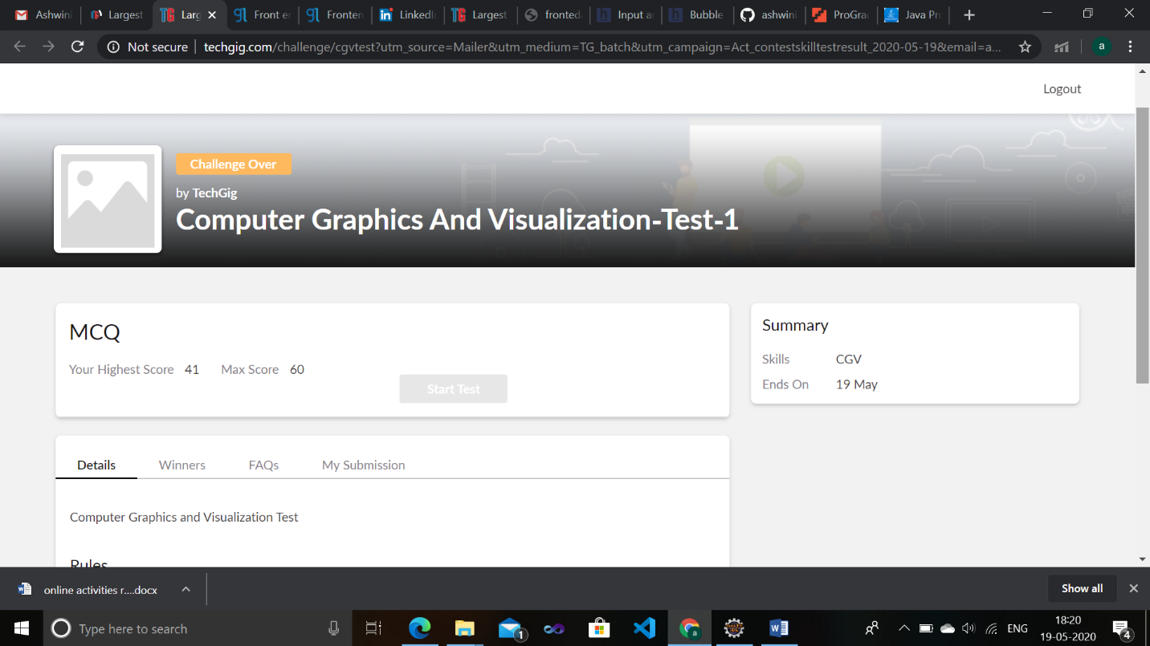

Certification Course Details:

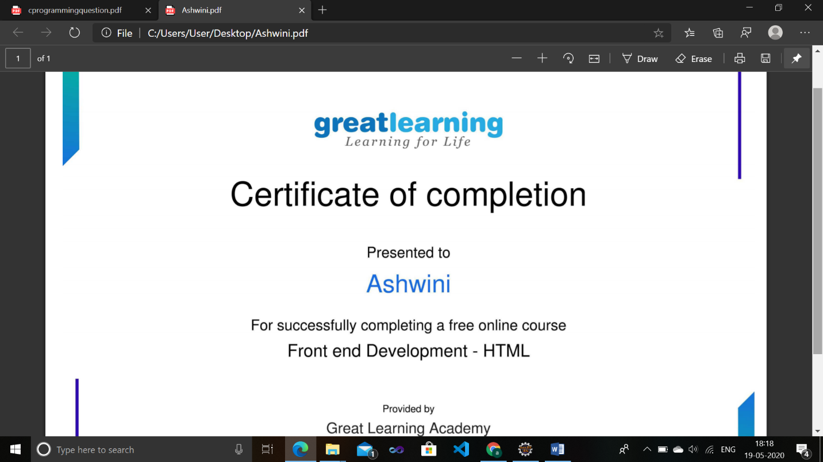

Coding Challenges Details:

